**ASSIGNMENT 1**

1, 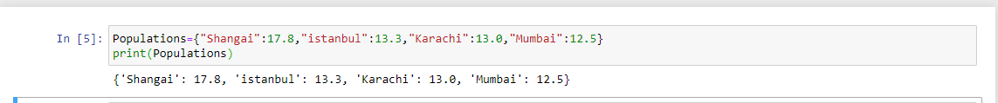

2,

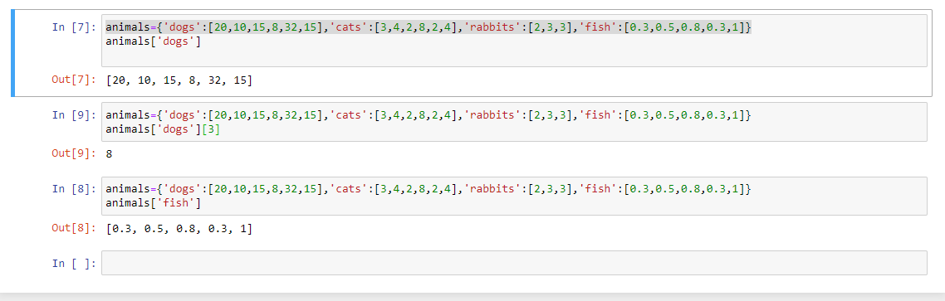

3, 

4, 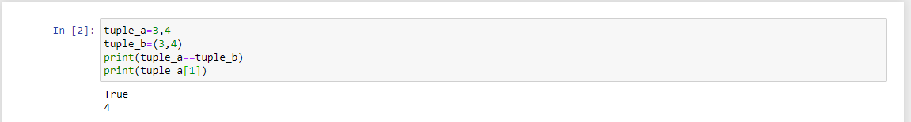

5,

